Lab 9: Data Aggregation
Week 5 Lab Output Result
Alan B. Palayil
University of the Cumberlands
Course: ITS836 – Big Data Analytics
Instructor: Dr. Charles Edeki
Date: November 26th, 2025

1. Dataset Selection and Loading
For this lab, I wanted to work with a medicinal plant dataset from Kaggle:
Dataset: edwardgaibor/pfaf-medical-plants-use-dataset (Selected with ChatGPT’s help)
Using kagglehub, I downloaded the dataset and recursively searched the dataset folder for the first CSV file. The script automatically detected:
- CSV file: pfaf_plants_merged.csv
- Rows: 17,950
- Columns: 27
Key columns included:
- Categorical:
- Numeric:
I printed the first 10 rows and the DataFrame shape for verification
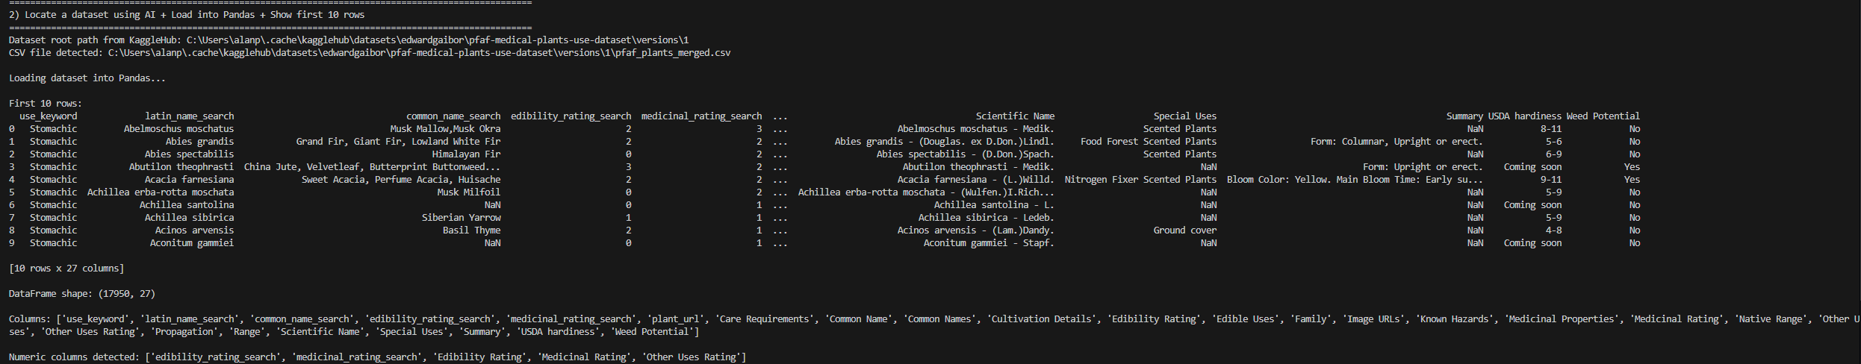

2. Aggregation Functions on Numeric Columns
I applied the following aggregation functions to all numeric columns using DataFrame.agg():
- count()
- first value (via lambda s: s.iloc[0])
- last value (via lambda s: s.iloc[-1])
- mean()
- median()
- min()
- max()
- std()
- var()
- sum()

Main findings from the aggregation results:
For the search-based numeric columns:
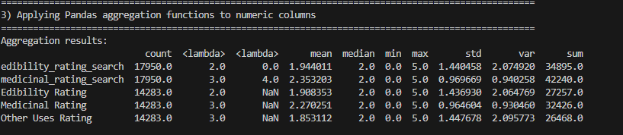

What the aggregation functions revealed:
- Ratings for edibility, medicinal use, and other uses are all on a 0–5 scale, with averages clustered around 2.
- The search-based rating columns (*_search) have more complete data (higher counts) than the original rating columns, suggesting these may be cleaned or merged versions.
- The relatively large standard deviations show a wide spread of usefulness across different plants—some have very low ratings while others score the maximum.
- The sum values (e.g., 42,240 for medicinal_rating_search) highlight the overall “medicinal usefulness mass” encoded in this dataset.

3. groupby() Analysis on a Categorical Column
For the groupby() step, I needed a categorical column with a reasonable number of unique values (between 2 and 20). The script automatically scanned object-type columns and selected:
- Groupby column: Weed Potential
  - Values: Yes / No
For the numeric column, I used:
- Target numeric column: edibility_rating_search
I then computed:
- count, mean, min, max, std per group, sorted by mean in descending order.
groupby results:
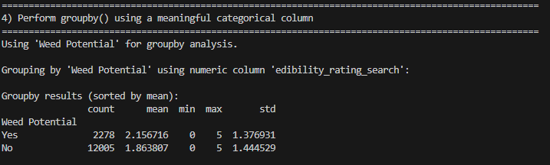

What the groupby analysis showed:
- Plants flagged as weeds (Weed Potential = Yes) have a higher average edibility rating (~2.16) compared to non-weeds (~1.86).
- Both groups share the same min/max range (0–5), but weeds seem slightly more edible on average, despite being undesirable or invasive.
- Standard deviation is similar in both groups, indicating a wide variety of edible potential within each category.
This suggests an interesting pattern: some plants considered “weeds” might still have significant edible value, which is relevant for ecological management, foraging, or permaculture discussions.

4. Reflection Summary – What I Learned

From the data and analysis:
- I saw how aggregation functions quickly summarize a large dataset:
  - count helps identify missingness or completeness.
  - mean, median, std, and var give a sense of central tendency and spread.
  - min, max, and sum highlight range and total “strength” of a variable in the dataset.
- The groupby() operation made it clear how one categorical dimension (here, Weed Potential) can reveal meaningful differences in numeric metrics like edibility rating.
- Working with this real-world medicinal plant dataset reinforced how numeric ratings and categorical labels together can encode complex domain knowledge (edible, medicinal, weedy, etc.).

From the coding perspective:
- I practiced using:
  - kagglehub.dataset_download() to programmatically pull a dataset from Kaggle.
  - os.walk() to recursively find a CSV when it isn’t in the root folder.
  - select_dtypes() to automatically discover numeric vs. categorical columns.
  - DataFrame.agg() with a dictionary of functions per column, including custom lambdas for first and last.
  - groupby() with chained .agg() and .sort_values() for readable summaries.
Importantly, I wrote and executed the final script myself, with ChatGPT acting as a helper for:
- Dataset discovery; Explaining errors and edge cases; and Suggesting idiomatic Pandas patterns.

